Quarterly Newsletter
Santa Clara
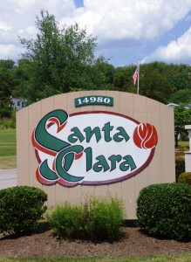

Upcoming Events

May
New Models to be unveiled in Phase IV in our Spring open house.

[Date]
[Event Name]

Greetings Residents;
This is our second installment of the Santa Clara Newsletter. I hope that the new year brings peace and joy to all our residents.
Welcome.
Since I have come onboard as the new Community Manager we have had several new Residents move into our community. The Santa Clara Community would like to extend a warm welcome to Mr. and Mrs. Lindstrom, Mrs. Pfiller, Mr. and Mrs. Salvatore, and Mr. and Mrs. Hedrick.
There are some homes in our community that are for sale privately. Remember that even though you are selling your home either through a Real Estate Agent, or by homeowner, the potential buyers must submit a rental application and go through the rental process to be approved for our community.
Phase IV
Utilities to the new phase are complete. The Lots have been graded and we await the new homes and models. We are planning for their arrival to begin sometime late March, with an open house during the Month of May. See below for resident incentives!
Spring Time
Winter is quickly coming to a close, Spring will be upon us before we know it. Since we have had a mild winter the ground has not had the chance to freeze solid for an extended period of time. This dear resident’s means that the insect population that burrows into the ground for their long winter nap did not perish during the winter months. Plan on dealing with a difficult insect problem this summer.
This is a good time to take a look around your home for any damage that occurred over the winter, and plan necessary repairs and improvements to keep your home in top condition and the community looking beautiful.
I would like to thank all the residents for their cooperation during salting and snow removal operations.
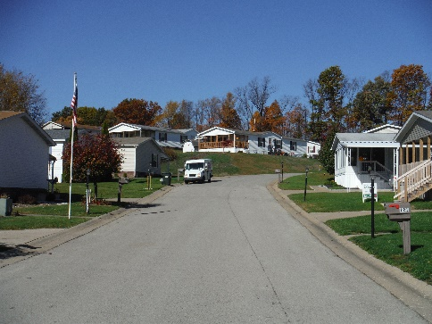

In the Community

Homeowners issues
We have a small, but growing list of contractors that some of our community residents use for various projects. If you are in need of a qualified professional and are unsure of where to turn contact the office. We will be happy to assist.
Reminder Notices
There is some confusion among some residents who have received reminder slips about various issues regarding their properties. With the hectic pace of normal life, sometimes simple everyday issues go unnoticed, or forgotten about. That is why management at Santa Clara sends out these reminders. Please do not feel threatened in anyway if you receive one, they are given to assist you in the upkeep of your property and our community. If the issue persists, of course action may need to be taken, but I promise you that will be dealt with in person. I encourage anyone who receives a reminder slip to contact me if you are unsure on why you received one, or how to proceed in rectifying the issue. I will gladly assist you in the matter.
Main Office
- The painting and installation of new carpet and vinyl in the main office is complete. New light fixtures have been added, new window treatments and furniture are right behind.
- If you recommend someone to Santa Clara that buys a Model, or new Home in the community you are eligible to receive two months free rent, or $500.
- Residents of the Community held a Super Bowl Party at the Rec. Center. Such a good time was had by all attendees that we will hold another one next year. Keep an eye out for info on our summer community picnic, details soon.
- In the next newsletter we will reveal the results of the recent resident survey. Residents still have until December 31st to turn in their survey sheets. What are we doing on this issue?
- If you have not updated your resident information forms, please do so. This will aid us in ensuring the safety of the community. You can get the forms from the office.
- If you notice any solicitors in the community try and get as much information about them as you can and forward it to the main office, I will contact the operation personally. If you feel they may be up to no good please contact the proper authorities.

Please email request to: b4mosa@santaclaraestates.comcastbiz.net

